BLACKHAWK BOWHUNTERS 2026
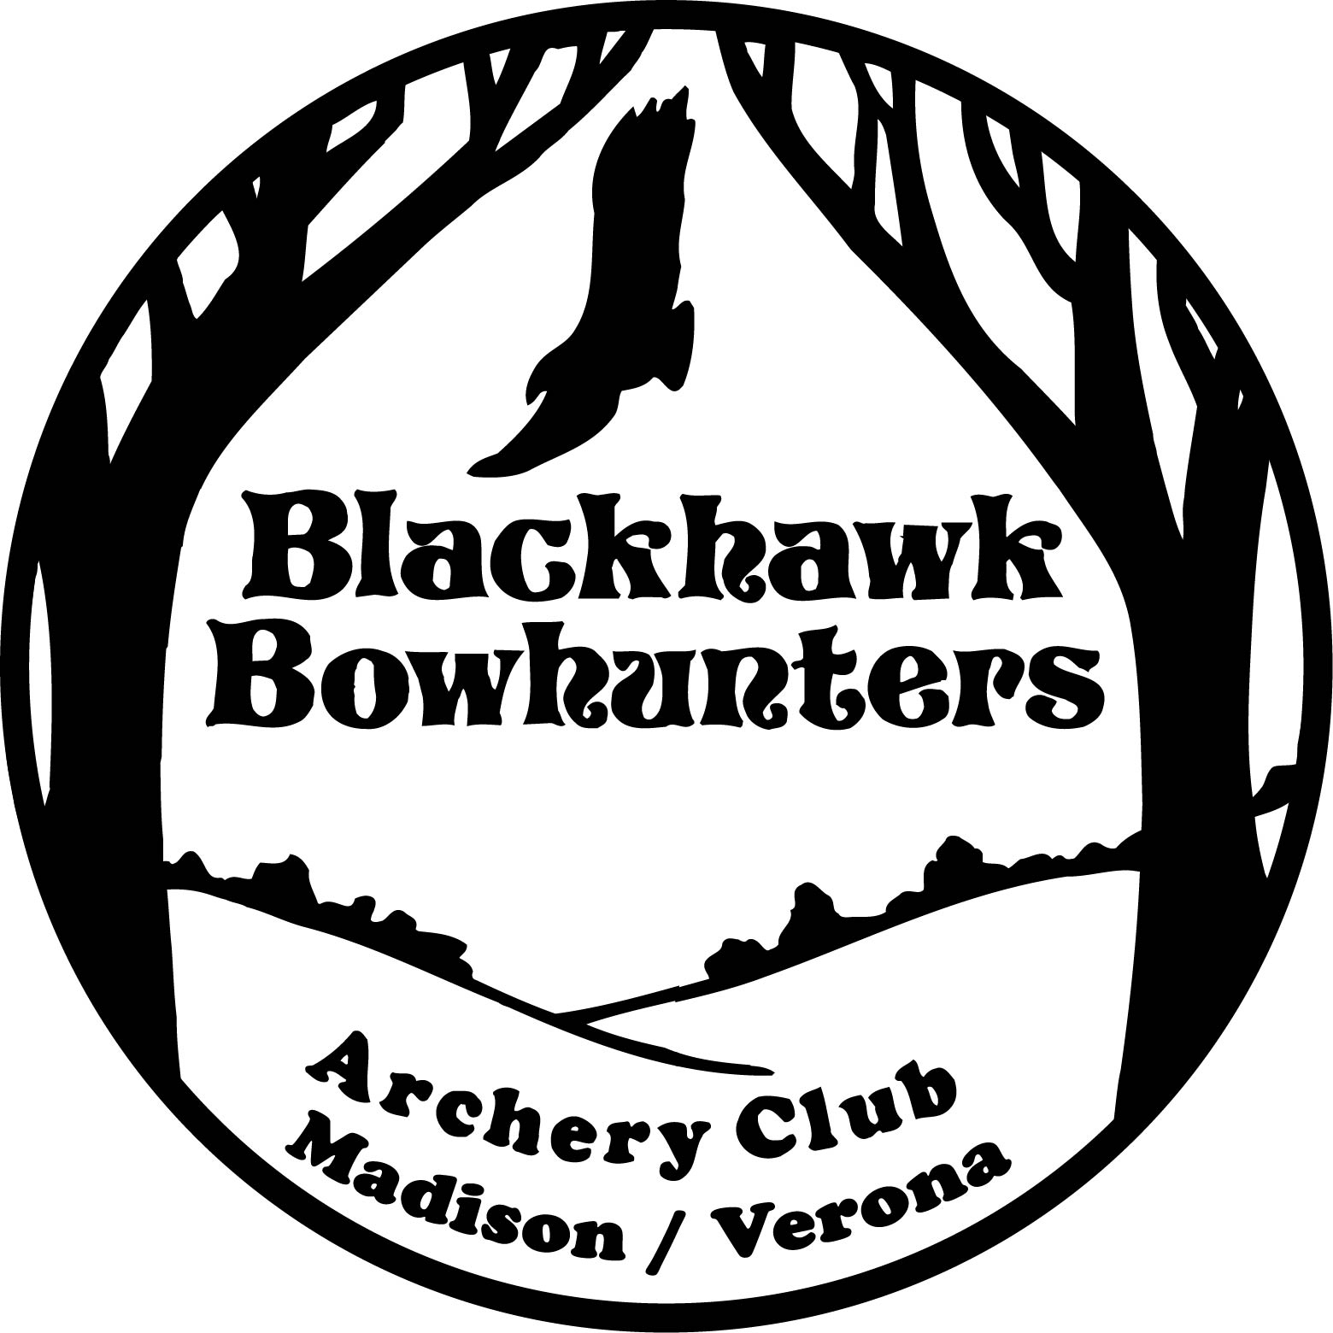

2103 County Trunk PB Verona, WI 53593
PH# (608)845-3960
WEBSITE: http://blackhawkbowhunters.com
E-Mail Address: mailbox@blackhawkbowhunters.com

MEMBERSHIP APPLICATION

About Blackhawk Bowhunters
- League shooting for Bowhunters, NFAA, Traditional, Bowhunters and Youth - Established Leagues!
  - Indoor & Outdoor shooting - Established Facilities!
  - Clubhouse has sixteen shooting lanes plus separate fellowship area (kitchen & bar)
  - Separate outdoor practice areas for target and broadhead
  - Outdoor broadhead/3D range and 14-target NFAA range
- Annual host to Blackhawk Open
- Non-profit organization so all money goes into facilities - Established Financially!
- Crossbow use is allowed. Blackhawk recommends X-bow shooters bring their own portable target to practice outdoors.

Annual Working Membership Plans (February 1, 2026 - January 31, 2027):
- Single $65 plus eight (8) hours of work on behalf of the club
- Family $90 plus twelve (12) hours of work on behalf of the club
- Youth $20 plus eight (8) hours of work on behalf of the club
(Must be under age 18 and provide signed statement of parental consent)
- Student $20 plus eight (8) hours of work on behalf of the club
(Must be a current student in a post high school program)
- Senior $30 plus eight (8) hours of work on behalf of the club (Must be age 65 or over)
- NON-WORKING MEMBERSHIP: Single $160, Family $235, Youth/Student $120, Senior $130
- Retired & Relocated Membership (R&R): Non-working, Single or Family $20,
(Must be a 5+ year Blackhawk member, retired, and no longer living in the area)

Six-Month Non-Working Membership Plans (August 1, 2026 - January 31, 2027):
- Single $110, Family $175, Youth/Student $80, Senior $80

WORK HOURS NOTE: Members are responsible to log their “Hours Worked” in the logbook at http://www.blackhawkbowhunters.com/blackhawkwork.html. The logbook can also be found under the “Work Opportunities” tab on the Blackhawk Bowhunters Website. At the end of the year, a member is required to reimburse the club for any shortfall of hours worked at a rate of $17/hr.

NEW MEMBERS ONLY: Annual membership applications received on or after December 1 will be treated as an annual membership application for the next membership year and will receive the remainder of the current year at no cost or work requirement.

Blackhawk Bowhunters Membership Application

http://blackhawkbowhunters.com e-mail: e-mailbox@blackhawkbowunters.com PH# (608) 845-3960

BASIC RULES:
- CLUBHOUSE IS SMOKE-FREE.

- NO ALCOHOLIC BEVERAGES WILL BE SOLD WITHOUT A LICENSED BARTENDER ON THE PREMISES. ALCOHOL CANNOT BE BROUGHT ON TO BLACKHAWK PREMISES WITHOUT BOARD APPROVAL.
NO ALCOHOL USE BY UNDERAGE PERSONS (under 21 years old). It is the responsibility of all members to ask for proof of age if they feel someone is in violation. NO ALCOHOL USE ON RANGES.
VIOLATION of these alcoholic beverage rules will result in FORFITURE of membership.

- CROSSBOW USE is allowed. Blackhawk recommends X-bow shooters bring their own portable target to practice outdoors. Please contact a board member if any questions.

- RESPECT THE ADJOINING LANDS. We want to be a valued part of the community and that can only be accomplished when goodwill is established with our neighbors. Must draw bow below the shoulder.

- BROADHEAD USE: Broadheads are only to be used in the dirt bunkers left of the clubhouse.

- GUESTS: Each member is allowed to bring 1 or 2 guests with them to use the facilities one time and the guest is requested to become a member. Non-member(s) must be accompanied by a member and must pay a $5.00 per day shooting fee to use either indoor or outdoor ranges.

- SHOOT FEES: Shoot fees are to be deposited in the GREEN TUBE by the right most indoor range entrance door.
- $1.00 an hour fee for “indoor” shooting plus $1.00 per new target.
- $5.00 to shoot a complete 3D round on the outdoor range.
- $5.00 Non-member fee per day (see guests).

- CLUBHOUSE USE:
- Turn on only the lights that are needed. Turn off lights when you leave.
- Thermostat is set for minimum heat when indoor facilities are not in use (contact a Board Member if you find there is a heating problem).
- Be careful about what you throw down the toilet and drains. Water is hooked up to a mound system.

Ranges are periodically closed for shoots, clean-up, and repairs. The Board will try to keep the membership informed of these dates. Please check your Newsletter, Website calendar, or contact a Board member if questions.

- LOG WORK HOURS: You must log your work hours in the logbook at http://www.blackhawkbowhunters.com/blackhawkwork.html . The logbook can also be found under the “Work Opportunities” tab on the Blackhawk Bowhunters Website.

NOTE: WORKING MEMBERS will be assessed at the end of the year a $17 HR FEE FOR UNWORKED HOURS.
It is each member’s responsibility to pursue work opportunities- check your newsletters or Blackhawk’s website, Blackhawkbowhunters.com and click on Events for a listing of club tournament dates. If you can help at any tournament, or on the club cleanup day, contact President Tony Bickel. Also click on Board of Directors for phone numbers of areas/events you are interested working in (Kitchen, Maintenance, Leagues, Tournaments, etc.).

PICK-UP/CLEAN UP AREAS BEFORE YOU LEAVE.
IF YOU ARE THE LAST TO LEAVE THE PREMISES, IT’S YOUR RESPONSIBILITY TO
MAKE SURE THAT THE CLUBHOUSE & GATE ARE LOCKED.

NOTE: Blackhawk Bowhunters will not publish any member info. nor sell it without your permission.

COME OUT AND ENJOY BLACKHAWK BOWHUNTERS. IT’S A GREAT PLACE TO MEET NEW PEOPLE!

Blackhawk Bowhunters Code of Conduct
Archery Range Code of Conduct
1. Safety First
- Always follow the range officer’s or group leader’s instructions.
- Never point a bow at anyone, even if it is not loaded.
- Only nock arrows when on the shooting line and after the signal to shoot has been given.
- Cease shooting immediately if anyone calls “Cease Fire” or if someone is downrange.
- Inspect your equipment before use. Damaged bows or arrows must not be used.
- No running on the range at any time.
2. Respect the Range and Others
- Treat fellow archers, staff, and visitors with courtesy and respect.
- Wait your turn and do not distract others while they are shooting.
- Keep noise to a minimum during shooting rounds.
- Do not touch another archer’s equipment without permission.
3. Range Etiquette
- Only retrieve arrows when the range is clear, and the signal is given.
- Stand behind the waiting line when not shooting.
- Mark your arrows for easy identification.
- Clean up after yourself—dispose of trash and return borrowed equipment.
4. Age and Supervision
- Minors must be supervised by a parent, guardian, or coach always.
- New and Beginner archers must read and understand all safety rules before using the range and facilities. Such information is posted and is available online. It is the responsibility of the parent, guardian, or coach to ensure these rules are understood and followed.
5. Prohibited Behavior
- No horseplay, roughhousing, or intoxication on the range.
- Broadhead shooting allowed ONLY in the outdoor broadhead pit
- Crossbow shooters are responsible for ensuring their target will not allow pass through’s
- Firearms are explicitly prohibited.
- Harassment, bullying, or discrimination of any kind will not be tolerated.
6. Liability and Responsibility
- All archers must sign a waiver before participating.
- You are responsible for your own equipment and conduct.
- The range is not liable for lost or damaged personal items.

Archery Range Code of Conduct: Preventing Physical and Sexual Harassment
1. Our Commitment
We are committed to fostering a safe, respectful, and inclusive environment for all archers, coaches, staff, volunteers, and visitors. Harassment of any kind—physical, verbal, or sexual—will not be tolerated.

2. What Constitutes Harassment
- Physical Harassment: Unwanted physical contact, intimidation, blocking movement, aggressive behavior, or threats of violence.
- Sexual Harassment: Unwelcome sexual advances, request for sexual favors, inappropriate comments, jokes, gestures, or any behavior/conduct of a sexual nature that makes others feel uncomfortable or unsafe or creates a hostile environment.

This includes behavior on and off the shooting line, in the clubhouse, restrooms, shooting ranges, parking lots, and during events or travel associated with the Blackhawk Bowhunters, or any event sponsored or affiliated with Blackhawk Bowhunters

3. Expected Behavior
All individuals must:
- Respect personal space and boundaries—no unwanted touching or close physical contact.
- Use respectful language—no sexual jokes, comments, or suggestive remarks.
- Maintain professionalism—especially in coach-athlete or adult-youth interactions.
- Report concerns to the Board of Directors. If you witness or experience harassment, speak up.
  - If you are not comfortable speaking for yourself, please seek out a trusted Blackhawk member, or an outside advocate that can bring the issue to the Boards attention.
- Treat others with dignity and respect always.

4. Unacceptable Behavior
The following are strictly prohibited:
- Unwanted touching, hugging, or physical proximity. Groping, brushing against someone intentionally, or any non-consensual contact
- Sexualized comments about appearance, clothing, or body. Sexual jokes, comments, gestures, or innuendos.
- Sharing or displaying sexually explicit materials. Taking photos or videos without consent.
- Stalking, following, intimidation, coercion or making someone feel unsafe.
- Retaliation against anyone who reports harassment.

5. Reporting and Response
- All reports will be taken seriously, treated confidentially, and investigated promptly.
- Concerns can be reported to a range official, coach, board member or other designated program leader.
- Reports will be managed confidentially, promptly, and without retaliation.
- Anonymous reporting options may be available.

6. Consequences
Violations of this Code may result in:
- Verbal or written warnings
- Immediate removal from the range
- Suspension or permanent ban
- Termination of coaching or volunteer roles
- Legal action or referral to law enforcement, if necessary

8. Acknowledgment
All members and participants are required to read, understand, and agree to this Code of Conduct as a condition of participation.

BLACKHAWK BOWHUNTERS 2026 Membership Application

MEMBERSHIP TYPE:
Check One:  WORKING Membership  NON-WORKING Membership
Check One:  ANNUAL Membership  SIX-MONTH Membership
Check One:  Single  Family  Youth  Student/Senior  R&R

NAME: HOW LONG A MEMBER? YRS.

ADDRESS: _________________________________ CITY: ____________________________ STATE: _______ ZIP: _______

E-MAIL ADDRESS: _____________________

PHONE#:
How did you hear about the club? _______________
What type of bow do you normally shoot? Crossbow - Compound -- Traditional -- Compound/Traditional

LIST NAMES OF IMMEDIATE FAMILY MEMBERS WITHIN YOUR HOUSEHOLD WHO WILL BE USING THE FACILITY:
Family Membership will consist of a head of house, spouse, and children under the age of eighteen on or before the date of application for membership, or a combination thereof, or a couple living at the same address.

LIFE PARTNER NAME: ______________ _ _ _ _ _ _ _ _ _ _ _ _ _ _ _ _
YOUTH NAME + DATE OF BIRTH: _____________ _ _ _ _ _ _ _ _ _ _ _ _ _ _ D.O.B. ____________ _ __
YOUTH NAME + DATE OF BIRTH: _____________ _ _ _ _ _ _ _ _ _ _ _ _ _ _ D.O.B. ____________ _ __
YOUTH NAME + DATE OF BIRTH: _____________ _ _ _ _ _ _ _ _ _ _ _ _ _ _ D.O.B. ____________ _ __

MEMBERSHIP WORK OPTIONS:
Blackhawk Bowhunters has achieved success because of the efforts of its members. We believe that each member has valuable skills to contribute. Please consider the following areas of interest in which you would like to offer to help:

Club Shoots Kitchen/Bar Maintenance/Landscaping Youth Programs

WAIVER: I understand that archery can be a dangerous activity if safety rules are not followed. I agree that I, and any guests that I bring to the club, will abide by the rules listed on page 2 of this member application and will use club facilities at our own risk.

____________________________ ___________ ____________________________ _________
Signature Date Life Partner Signature Date
Youth Membership Parental Consent: I am the parent/legal guardian for ________________ whose birthdate is _______ and I give my consent to join Blackhawk Bowhunters. I agree that my Youth will abide by the rules and will use club facilities at our own risk.

_______________________________ __________
Parental Signature Date
(Youth members under the age of sixteen, MUST be accompanied by an adult at ALL times.)

Acknowledgment – I have read, understand, and agree to the Blackhawk Codes of Conduct as a condition of participation.

_______________________________ __________
Signature Date

Make checks payable to Blackhawk Bowhunters and mail along with page 5 of this completed form to:
Ann Gleisner
577 Fairview Ter
Verona, WI 53593
(608) 576-8590

